http://www.yourhikeguide.com/white-pocket/

You are at:Home»National Parks & Monuments»Vermilion Cliffs National Monument»White Pocket
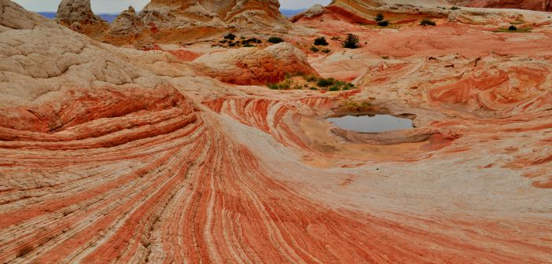

White Pocket
19
By Adam on February 20, 2014 Vermilion Cliffs National Monument
If you’re looking for a remote location with amazing rock colors and formations and little foot traffic, then White Pocket is the perfect place. Now this place isn’t for the unprepared. You will need to have a 4WD vehicle, preferably with high clearance. You’ll be driving through deep sandy roads for at least an hour and a half off the main House Rock Valley Road. Be sure to check the current conditions of the road at the BLM Office located at 745 East Highway 89. This is a great trip to do in conjunction with the Wave or Buckskin Gulch.

White Pocket Hike Details
Distance – 1+ miles roundtrip
Approximate hiking time – Varies on how much time you want to spend there
Elevation at Trailhead – 5646 feet
Difficulty – Easy
Trail – Sand and sandstone
Amount of water recommended – 2+ liters
Bathrooms – None
Season to hike – Year-around if road is passable due to deep sand.
Special considerations – A 4WD vehicle is necessary, high clearance is recommended.
Permits – None needed at this time
What to bring? – printable hiking checklist

How to get there:
The first thing to do is to stop at the Kanab Visitor Center at 745 East Highway 89, and ask about the road conditions to White Pocket. They also have a detailed map to White Pocket as you’ll be traveling for an hour and a half on dirt and deep sandy roads.
From Kanab, Utah take US-89 east for 39 miles. The road will take a sharp curve to the right (south) and then make another sharp curve to the left (east). House Rock Valley Road is a gravel road that turns off and goes straight instead of taking the tight curve that goes east. There is a sign to help you make the turn off. Use your turn signal early as there is no turn lane.
If coming from Page, Arizona, take US-89 north/west for 33 miles from the Glen Canyon Dam. At about 32.5 miles from the Glen Canyon Dam on US-89 the road will make a tight curve to the north, when you nearly completed the curve the turnoff onto House Rock Valley Road will be on the left side of the road.
Head down House Valley Rock Road for 20.2 miles. The road is rough and prone to washouts. At 20.2 miles, you will turn left at an old corral onto Pine Tree Road/Road 1017 and head east for 6.2 miles, avoiding all side roads. You will then come to a farm house. You will turn left as the road will go in front of the farm house and begin to head north. This is Road 1087. At approximately 3.9 miles from the farm house you will take the left fork and continue on the left fork for 5.6 miles before you arrive at the White Pocket parking area. Along the way you’ll come to a cattle fence crossing the road. Close the fence behind you. It should take about 90 minutes to get to White Pocket after turning off House Rock Valley Road.
If coming from the south on US-89A, turn right onto House Rock Valley Road, and head north. There are two older businesses right off the turnoff. Take House Rock Valley Road for about 9.2 miles until you see an old corral on your left. Turn right here and follow the directions listed in the paragraph above.

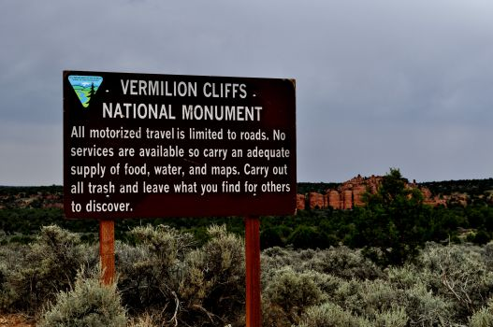
White Pocket is very remote. Have all the necessary provisions before you go.

(See the Google Map for this hike at the end of the post)

Hitting the Trail!
You may not understand just how remote this place is until you finally pull up to the trailhead. The parking area is a large, but you’ll never see more than a couple of cars at most. If you’re looking for solitude, this is your place.
While White Pocket has been getting increased media attention recently, it is still far enough off the main highway to limit the number of visitors.
There is a sandy trail that leads for about 100 yards from the parking area. After that, there is no set trail, as you are free to explore along the colorful slickrock. You can easily spend several hours exploring the formations tucked in and around White Pocket. The traverse across the slickrock is easy and fun, and each step is a view to something unique and picturesque.

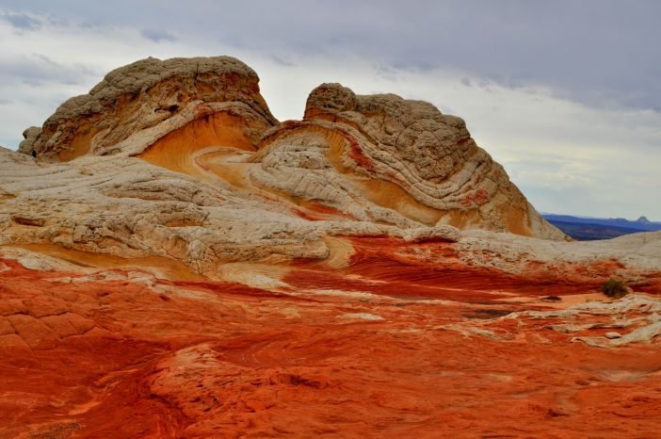
You could stand in one place, and in each direction there was something amazing to see

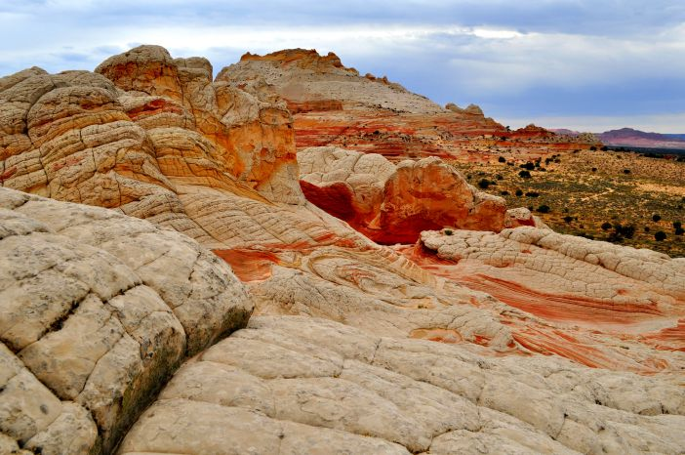
There’s a good chance you’ll be the only ones at White Pocket

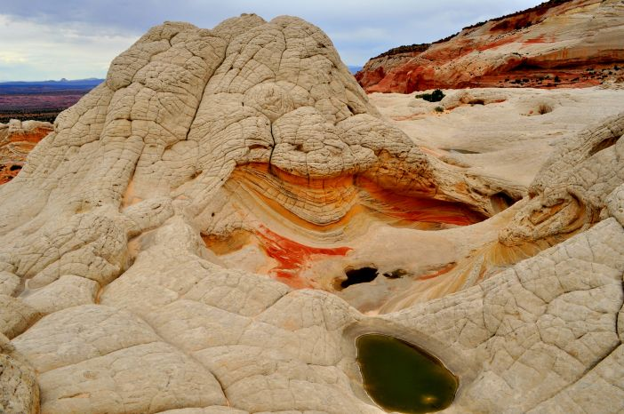
I’m not sure if it’s possible to take a bad picture here

White Pocket is best photographed in sunny weather conditions, as the blue skies contrast nicely with the colors in the rock. As with any place in the southern Utah/northern Arizona, the temperature reaches into the 100’s in the summer at White Pocket so bring plenty of water, food, and an accurate map.

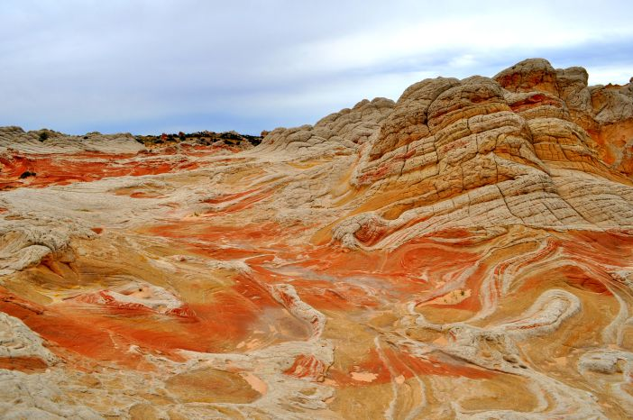
White Pocket needs to be on your Bucket List!

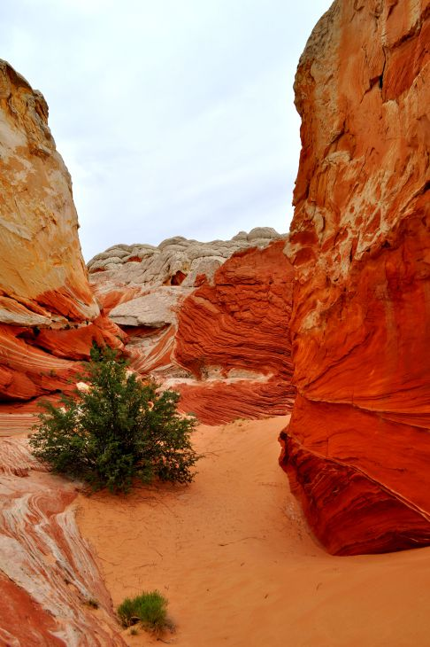
White Pocket has different and unique colors with every footstep

